Code generation

Yii2 provides the powerful module Gii to generate models, controllers, and views, which you can easily modify and customize. It’s a really helpful tool for fast and quick development.

In this section we will explore how to use Gii and generate code. For example you have a database with one table named film and you would like to create an application with CRUD operations for this table. It’s easy.

Getting ready

1. Create a new application by using composer as described in the official guide at <http://www.yiiframework.com/doc-2.0/guide-start-installation.html>.

2. Download the Sakila database from [http://dev.mysql.com/doc/indey-other.html](http://dev.mysql.com/doc/index-other.html).

3. Execute the downloaded SQLs: first the schema then the data.

4. Configure the database connection in config/main. php to use the Sakila database.

5. Run your web-server by ./yii serve.

How to do it...

1. Go to http: //localhost :8080/index. php?r=gii and select Model Generator.

2. Fill out Table Name as actor and Model Class as Actor and press button Generate at the bottom of page.

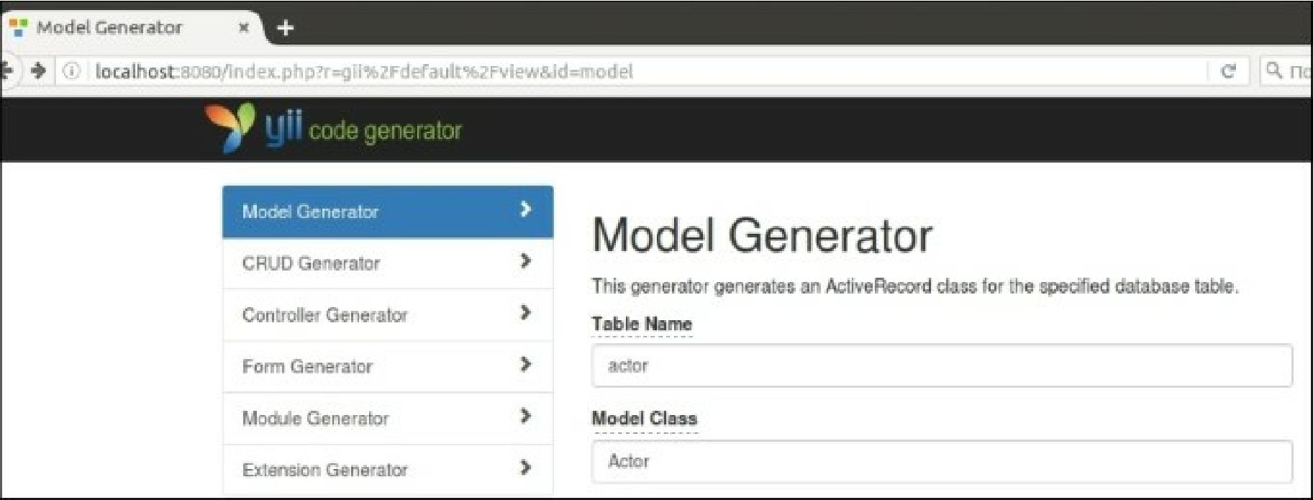

3. Return tothe main Gii menu by clicking the yii code generator logo on the header and choose CRUD Generator.

4. Fill out the Model Class field as app\models\Actor and Controller Class as app\controllers\ActorController.